

**Architecture Document**

**Quality Assessment on Enterprise Linked Data**

**Created By:**

**Carlos Montoya**

**Rauf Aghayev**

**Vugar Aghayev**

Enterprise Information Systems Department

EIS-LAB

*Bonn, September 2014*

**Content**

1 INTRODUCTION 5

1.1 Problem Definition 5

1.2 Objectives 5

1.3 Document Structure 5

2 Use cases 7

2.1 Use Case 1: Drugstore Online. 7

2.2 Use Case 2: Online Computer Store. 8

2.3 Use Case 3: Hotel Reservation System. 8

2.4 Metrics Definition 9

2.4.1 Metrics definitions for the new Dimensions 9

2.5 Requirement Specification 9

3 conceptual FRAMEWORK 13

3.1 RDF 13

3.2 Apache Jena 13

3.3 SPARQL 14

3.4 MAVEN 15

3.5 JUnit 15

3.6 JSF 16

3.7 RichFaces 16

3.8 EJB3 17

3.9 Apache Ant 17

4 application Structure 19

4.1 Modules Structure 19

4.2 Project Structure 20

4.2.1 EIS-LAB Project. 20

4.2.1.1 src/main/java 21

4.2.1.2 src/main/resources 22

4.2.1.3 src/test/java 22

4.2.2 Metrics Explanation 23

4.2.3 EIS-LAB-INTERFACE Project 27

4.2.3.1 Src Folder: 27

4.2.3.2 WebContent Folder: 28

4.2.3.3 Ant Files 29

5 TESTING 30

5.1 JUnit Test 30

5.2 Performance Test 31

6 INTALLATION AND USER MANUAL 33

6.1 INSTALLATION FOR DEVELOPMENT 33

6.1.1 Eclipse 33

6.1.1.1 Configuration 33

6.1.2 JBoss 4.2.3 GA 34

6.1.2.1 Configuration 34

6.1.3 Maven 34

6.1.3.1 Configuration 34

6.1.4 Run the program on the server 34

6.2 USER MANUAL 35

6.2.1 Flow of the program. 35

6.2.2 How to Access and use the program. 36

6.2.2.1 Visualize results 37

6.2.2.2 Evaluate new Dataset 39

7 REFERENCES 40

[i]. 40

**Figure Index**

Illustration 2‑1, Use Case, Scenario 7

Illustration 3‑1, Apache Jena Specification 14

Illustration 4‑1, General Architecture 19

Illustration 4‑2, EIS-LAB Project structure 20

Illustration 4‑3, src/main/java packages 21

Illustration 4‑4, src/main/resources folders 22

Illustration 4‑5, src/test/java packages 22

Illustration 4‑6, EIS-LAB-INTERFACE structure 27

Illustration 4‑7, WebContent structure 28

Illustration 6‑1, Projects imported 33

Illustration 6‑2, config.properties file 34

Illustration 6‑3, ant.properties - JBoss path 34

Illustration 6‑4, ant.properties - Maven path 34

Illustration 6‑5, ant build view 35

Illustration 6‑6, Sequence diagram 36

Illustration 6‑7, Init screen 37

Illustration 6‑8, Available dimensions 37

Illustration 6‑9, Metrics select combo 38

Illustration 6‑10, Available Datasets 38

Illustration 6‑11, Result Image 38

Illustration 6‑12, Evaluate new dataset 39

# INTRODUCTION

## Problem Definition

During the development of Web Semantic technologies huge volume of data has being published on the web as a Linked Open Data. In order to use LOD for specific purpose, we should check its quality in advance. The quality term means in Semantic Web is fitness of use. Then we should have into account that not all the data is meaningful and if the quality is poor it leads to Enterprise problems such as data standardization, multiple data with duplicates in the data sets, meaningless information and so on.

To assure that the Enterprise is trustful, and then in the design we should take into account that the quality measurement depends on which domain the data will be used. On the other hand, we should assure that our LOD the data is measure for the correct quality metrics, which means that the given data in one LOD be useful for one of the use cases but not favorable for other ones. Therefore, for measurement of LOD we are going to use metrics and we identify the fitness of it use.

## Objectives

The main goal of this document is to present the design of the application developed to accomplish the Quality Assessment on Enterprise Linked Data.

The process defines is compound by two sub problems:

* Streaming of Enterprise SPARQL Endpoints.
* Computation of the Quality Metrics over the SPARQL Endpoints.

Achieving these two parts, the values of the SPARQL endpoint should be visible through a user interface, which should be able to show the Metric Value against the SPARQL endpoint.

## Document Structure

This document is structure as follow:

* The chapter one is the introduction, establishing the main purpose of the document and what to expect of it.
* The chapter two is the specification of the different scenarios (Use Cases), which were used to find the solution to the problem.
* The chapter three is the conceptual framework of the application, emphasizing on the technologies used in the project.
* The chapter four explains the structure of the Project and the detail of all the modules.
* The chapter five explained how to install the project and how to use it.
* The chapter six explained how to install the project and how to use it.
* The chapter seven describes the testing units that were used to test the classes and the performance of the project.

# Use cases

## Use Case 1: Drugstore Online.

Based on the fact that there is some people who cannot go out because they suffer from some illness or they are recovering at home of some kind of medical treatment. Then they need a service that provide cheaper and trustful medicaments online that can be send easily to their home. For that reason the use case is related with the creation of a Drugstore Online which obtains information of different websites (providers) and then shows the best options to the user. Of course in order to offer a medicament or a treatment we must be able to check the quality of the data that we display on the screen.

We must be able to check in advance the data quality, for that reason we should be able to use the metrics (initial approximation):

1. Verifiability
2. Reputation
3. Believability
4. Consistency
5. Availability
6. Understandability
7. Conciseness
8. Volatility

The next image describes the basic uses cases that the enterprise system requires.

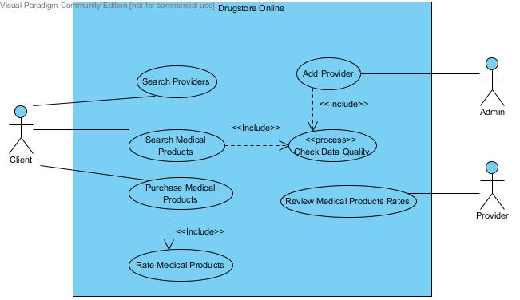

Illustration 2‑1, Use Case, Scenario

## Use Case 2: Online Computer Store.

During the improvement of information technologies, approximately every person uses Computer, Tablet, Telephone, etc. In addition, they prefer, buy such kind of devices online for getting lower prices. Our use case related with this situation. We want to create Online Computer Store, which gets information about Computers from different web sites and shows customers. In order to achieve this, we should check quality of data in advance. On the other hand, we apply some metrics which fit our requirements, to the given data and then we decide data is usable or not.

Metrics:

1. Completeness
2. Amount of Data
3. Relevancy
4. Verifiability
5. Reputation
6. Believability
7. Response time
8. Availability
9. Understandability

## Use Case 3: Hotel Reservation System.

My use case is about intelligent hotel reservation system which aggregating data from several data sources, websites. It gets information about location of countries, cities and particular addresses from a spatial dataset and information about hotels from a hotel dataset. Additionally, all related information about hotels gathered from different booking services and represented as RDF. This integrated dataset allows user to find a suitable hotel between any arrival and departure time for his/her wonderful vacation.

1. The use case that we are going to develop is the related with Check Data Quality.
2. Availability
3. Licensing
4. Interlinking
5. Security
6. Performance
7. Accuracy
8. Consistency
9. Conciseness
10. Reputation
11. Believability
12. Verifiability
13. Objectivity
14. Understandability
15. Versatility

## Metrics Definition

### Metrics definitions for the new Dimensions

The Enterprise systems have already other dimensions to assure the quality of the information that they use. For that reason here you can find a small list that is related with the quality measurement.

1. Easy of Manipulation
   1. Keeping URIs short
   2. Mixed metrics between believable and reputable dimensions
2. Free of Error
   1. Dereferencability issues
   2. Erroneous annotation/representation erroneous
   3. Inaccurate annotation, labeling, classification
3. Value-Added
   1. Evaluation by the expert users
4. Temporal Reliability
   1. Meaning and semantics changes over time
   2. Look for loss of history data with no record of previous values

## Requirement Specification

|  |  |  |  |
| --- | --- | --- | --- |
| **Requirement Name** | Process Data Quality | | |
| **Main Users** | System and Admin | **Priority** | High |
| **Author** | Carlos Montoya | **Creation Date** | 14-05-204 |
| **Revision Date** |  | **Modifications Date** |  |
| **Summary** | The data that display the main system of the company, should be check in advance, this use case is in charge to measure the data sets quality, by measuring the dimensions of: Free of Error, Verifiability and Measurability. After verify those metrics, the system should be able to display the values obtained and the user should be able to compare those values between each other. | | |
| **Main Track Events** | | | |
| **User** | | **System** | |
| 1. The user access the program. | | 2. The system displays the name of the dimensions to be evaluated, under the question "Please chose a Dimension", those are shown as a combo box, and the options are: 1st Verifiability, 2nd Free of Error and 3rd Measurability. | |
| 3. The user selects one of the dimensions displayed. | | 4. Depending of the option selected, the system should display a new combo box with the metrics to be evaluated. The system has three different cases (depending on the dimension selected). | |
|  | | 4.1 When the user choose Verifiability, then the system show the metrics: 1st Authenticity of the dataset, 2nd Usage of digital signatures. | |
|  | | 4.2 When the user choose Free of Error, then the system show the metrics: 1st Dereferencability issues, 2nd Erroneous annotation/representation erroneous. | |
|  | | 4.3 When the user choose Measurability, then the system show the metrics: | |
| 5. The user select one of the metrics displays in the point 4. | | 6. The system now shows the different dataset available to be evaluated under those metrics. They show the options under a multiple select box. The datasets are: DATASET1, DATASET2, and DATASET3. | |
|  | | 7. When the user select at least one dataset the system display the bottom "evaluate" | |
| 8. The user press the button "evaluate". | | 9. The system should display a graph where is easy for the user to identify the metrics vs the datasets. And each dataset is easy to identify. | |
|  | |  | |
| **Alternatives Tracks** | | | |
|  | | | |
|  | | | |
| **Exception Tracks** | | | |
| After the user in the point 8 select the information for evaluate and the info of the evaluation is not available, then the system should display a message "The information is not available right now, please choose another dataset or another metric." | | | |
|  | | | |
| **Extension Points** | | | |
|  | | | |
|  | | | |
| **Pre - Conditions** | | | |
| To display easily and fast the information of the results of the evaluation of the metrics, those values (metric values) should be evaluated in advance and those result should be saved into some media that should be defined by the development group. | | | |
| The selected datasets to be evaluated should be free of access, and then the development is not going to violate any copyright of the information used. | | | |
|  | | | |
| **Post- Conditions** | | | |
| All the datasets are evaluated and these results are store in an accessible media to be used by another use cases. | | | |
|  | | | |
| **Considerations** | | | |
|  | | | |

# conceptual FRAMEWORK

Shown below are explained all the technologies uses for the development of the application of Quality Assessments.

## RDF

RDF is a standard model for data interchange on the Web. RDF has features that facilitate data merging even if the underlying schemas differ, and it specifically supports the evolution of schemas over time without requiring all the data consumers to be changed.

RDF extends the linking structure of the Web to use URIs to name the relationship between things as well as the two ends of the link (this is usually referred to as a “triple”). Using this simple model, it allows structured and semi-structured data to be mixed, exposed, and shared across different applications.

This linking structure forms a directed, labeled graph, where the edges represent the named link between two resources, represented by the graph nodes. This graph view is the easiest possible mental model for RDF and is often used in easy-to-understand visual explanations.[1]

## Apache Jena

Jena is an open source Semantic Web framework for Java. It provides an API to extract data from and write to RDF graphs. The graphs are represented as an abstract "model". A model can be sourced with data from files, databases, URLs or a combination of these. A Model can also be queried through SPARQL and updated through SPARUL.[2]

Its Architecture includes:

* API to work (read, process, write) ontologies RDF and OWL.
* Engine of inference for rezoning over ontologies RDF and OWL.
* A strategy to flexi storage for RDF triples in memory.
* Query engine compatible with SPARQL.

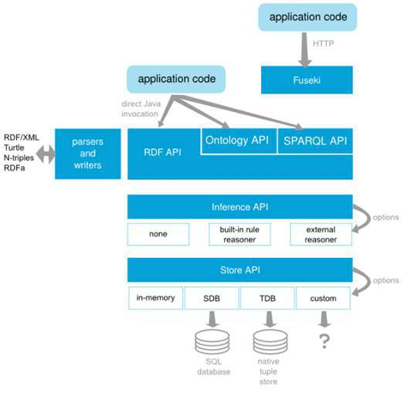

Illustration 3‑1, Apache Jena Specification

## SPARQL

SPARQL: acronym for Simple Protocol and RDF Query Language is an RDF query language, that is, a query language for databases, able to retrieve and manipulate data stored in Resource Description Framework format. It was made a standard by the RDF Data Access Working Group (DAWG) of the World Wide Web Consortium, and is recognized as one of the key technologies of the semantic web[3].

SPARQL allows for a query to consist of triple patterns, conjunctions, disjunctions, and optional patterns.

## MAVEN

Maven, a Yiddish word meaning accumulator of knowledge, was originally started as an attempt to simplify the build processes in the Jakarta Turbine project. There were several projects each with their own Ant build files that were all slightly different and JARs were checked into CVS. We wanted a standard way to build the projects, a clear definition of what the project consisted of, an easy way to publish project information and a way to share JARs across several projects.

The result is a tool that can now be used for building and managing any Java-based project. We hope that we have created something that will make the day-to-day work of Java developers easier and generally help with the comprehension of any Java-based project.[4]

**Maven’s Objectives**

Maven’s primary goal is to allow a developer to comprehend the complete state of a development effort in the shortest period of time. In order to attain this goal there are several areas of concern that Maven attempts to deal with:

* Making the build process easy
* Providing a uniform build system
* Providing quality project information
* Providing guidelines for best practices development
* Allowing transparent migration to new features

## JUnit

JUnit is an open source framework designed for the purpose of writing and running tests in the Java programming language.

JUnit allows the developers to incrementally build test suites to measure progress and detect unintended side effects. Tests can be run continuously. Results are provided immediately. JUnit shows test progress in a bar that is normally green but turns red when a test fails. An ongoing list of unsuccessful tests appears in a space near the bottom of the display window. Multiple tests can be run concurrently. No subjective human judgments or interpretations of test results are required. The simplicity of JUnit makes it possible for the software developer to easily correct bugs as they are found.

## JSF

JavaServer Faces (JSF) is a [Java](http://en.wikipedia.org/wiki/Java_%28programming_language%29) specification for building [component](http://en.wikipedia.org/wiki/Software_component)-based [user interfaces](http://en.wikipedia.org/wiki/User_interface) for [web applications](http://en.wikipedia.org/wiki/Web_application).[[1]](http://en.wikipedia.org/wiki/JavaServer_Faces#cite_note-1) It was formalized as a standard through the [Java Community Process](http://en.wikipedia.org/wiki/Java_Community_Process) and is part of the [Java Platform, Enterprise Edition](http://en.wikipedia.org/wiki/Java_Platform,_Enterprise_Edition)[5].

JSF is based in the MVC pattern. The use of this framework is especially useful for the maintenance in comparison to the JSP and Servlets[6].

* JSF provide standard and reusable components for create user interfaces for web applications.
* JSF provide different libraries to the component’s access and manipulation.
* JSF saves automatically the page information and it fill it out when they are deploy on the client side.
* Today there are many different interfaces to simplify de development of web application based on JSF Framework.

The User Interfaces that are created with the technology JSF, run in a web server and it response is shown in a web client. The development using the JSF framework allow us to be focus it the creation of components for the user interfaces, event managed, backing beans and their interactions. And not to be focus it in the requests and responses processes from the client or from the server side.

## RichFaces

RichFaces is an open source library that enables the use of AJAX for JSF; RichFaces is developed by the JBoss.org community. This part allows the integration of capabilities of development for Enterprise applications.

RichFaces is not only a JSF component library, also it provides:

* Skin-ability (Capability to change and update the look and feel of the application).
* Components Development Kit (CDK) to assist the development of new components.

In the project we used the RichFaces version 3.3.4[7].

## EJB3

The Enterprise Java Bean (EJB) Technology is the component architecture of the server side JEE (Java Enterprise Edition). This technology allows the faster and easy development of distributed, transactional, safety and portables applications based on java.

The EJB specification tries to provide a standard way to develop the “back-end” of the business, typically is found in Enterprise applications. EJB was created with the aim of manage the common concerns related with persistence, transactional integrity and safety, in a standard form.

The specification show that the application should provide:

* Processing transactions.
* Persistence integration services offered by JPA.
* Concurrency control.
* Events using Java Message Service.
* Services Directory (JNDI[8]).
* Deployment of software components in an application server.
* Remote Procedure calls using RMI-IIOP.
* Business Methods Exhibition as Web Services.

## Apache Ant

Apache Ant is a software tool for [automating software build](http://en.wikipedia.org/wiki/Build_automation) processes. It is similar to [Make](http://en.wikipedia.org/wiki/Make_%28software%29) but is implemented using the [Java](http://en.wikipedia.org/wiki/Java_%28programming_language%29) language, requires the Java platform, and is best suited to building Java projects.

The most immediately noticeable difference between Ant and Make is that Ant uses [XML](http://en.wikipedia.org/wiki/XML) to describe the build process and its dependencies, whereas Make uses [Makefile format](http://en.wikipedia.org/wiki/Makefile#Makefiles). By default the XML file is named build.xml.[9]

# application Structure

## Modules Structure

The Quality application is a command line application with Java technology and Jena framework. As consequence the application contains uses the pattern MVC (Model, View and Controller).

In the next graphic we show how is built the project.

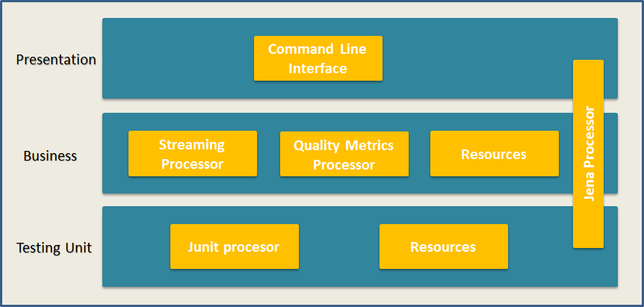

Illustration 4‑1, General Architecture

Inside the presentation layer we present the following components:

* User Interface: Is the owner of the interaction with the user, and is in charge to show the results of run all the metrics over the specified dataset.

The Business layer has the next components:

* The Streaming Processor is the owner of the process to connect to de SPARQL endpoint and stream all the data to be use by the quality metrics processor; it is solved using the parading of producer-consumer to make it faster in its processing.
* The Quality Metrics Processor is the processor who computes the values for all the quality metrics defined in the project.
* The content of Resources is used to load the model into the diachron data model, and work to load the advantages offered by Maven.

The Testing unit is compound by:

* The JUnit Processor that take advantages of all the tools offered by JUnit and we used to test our classes and assure its functionality.
* The resources are example datasets that were used by JUnit to make sure that our classes find the correct value of the metrics.

To make the communication between all the modules we used the tools provide it by Jena, such its classes and its tools to connect to the SPARQL endpoints.

All this classes are accessed in all the application and they are independent from the other packages.

## Project Structure

### EIS-LAB Project.

The Project is built by packages that contain all the modules necessaries to run the application and be able to use it. You can check in the next graphic.

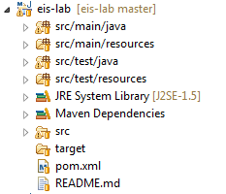

Illustration 4‑2, EIS-LAB Project structure

In the graphic you can see the folders:

* Src/main/java: This package contain all the classes that are need it to run the project, in in this package are defined the interface, the metric processor, the streaming processor.
* Src/main/resources: This package contains all the files that are required by maven to build the structure of the project.
* Src/test/java: This package contains all the unit test that were defined to test the classes contains in the main package.
* Src/test/resouces: In this package is stored all the resources that are used to test the classes, it contain some example datasets.
* Also we can check that the project contain a reference to a library that is call Maven Dependencies, it contain all the libraries that are uses by the packages described before.

#### src/main/java

This package as mention before contains all the classes that are necessary to run the project and it is compound by the next packages:

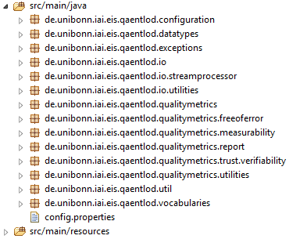

Illustration 4‑3, src/main/java packages

In the project the most important packages are:

* de.unibonn.iai.eis.qaentlod.io: In this package is the main class to be executed. It provided all the interface of interaction with the user and provide to the user with different functionalities.
* de.unibonn.iai.eis.qaentlod.io.streamprocessor: In this package are the classes that solve the problem of streaming a SPARQL endpoint, it solves this problem implementing the problem of producer-consumer.
* de.unibonn.iai.eis.qaentlod.qualitymetrics: This package contain all the metrics that are defined in our project, it has several subpackages that are:
  + freeoferror: this implements the metrics defined to be into the freeoferror dimension.
  + Trust.verifiability: this implements the metrics defined to be into the Trust dimension.
  + Measurabilty: this implements the metrics defined to be into the Measurabilty dimension.
* de.unibonn.iai.eis.diachron.vocabularies: This package includes all the information related with the vocabularies that are defined to be readable by the maven processor.

#### src/main/resources

These packages contain all the resources that are necessary to run on maven, it is compound by:

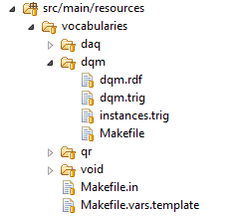

Illustration 4‑4, src/main/resources folders

The main folder is call vocabularies, it contains all the necessary files to specify into maven the languages that it should read and create its vocabulary.

Into the dqm.trig is the RDF specification of all the metrics and dimensions that should be taking it into account in the moment of evaluating all the metrics.

#### src/test/java

This folder is the one that contain all the information related with the unit test of the source code. The structure is built by the next packages:

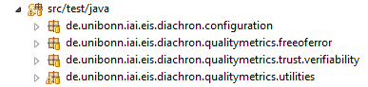

Illustration 4‑5, src/test/java packages

### Metrics Explanation

|  |  |  |  |  |  |
| --- | --- | --- | --- | --- | --- |
| **Requirement Name** | Quality Metric APIs documentation | | | | |
| **Priority** | High | | | | |
| **Author** | Rauf Agayev,  Vugar Aghayev | **Creation Date** | | | 30-08-2014 |
| **Revision Date** | 01-09-2014 | **Modifications Date** | | | 25-08-2014 |
| **Summary** | This section of documentation explains functionality of packages, classes and methods of Quality metrics. For clear information screenshots of those things are given. | | | | |
|  | | | | | |
| **Verifiability – Authenticity** | | | | **Explanation** | |
| package: **de.unibonn.iai.eis.qaentlod.qualitymetrics.trust.verifiability**  classes: *AuthenticityDataset*  *Digital signatures* | | | | The package trust.verifiability package contains the classes that are responsible of check the authenticity of the information. | |
| class: **de.unibonn.iai.eis.qaentlod.qualitymetrics.trust.verifiability.AuthenticityDataset**  methods: *public void compute(Quad quad){}*  *public double metricValue(){}* | | | | This class gets quads from some sources (sparql endpoint) and operates on them. The main purpose of the class is checking the provenance of the dataset. | |
| @*Override* **void** compute**(**Quad quad**)**  divide quad three parts: subject, predicate, object  **if** predicate is not **null** and predicate is URI and subject is not **null**   **then**   **if** *setProvenanceProperties* contains predicate’s URI   **then**   **String** curSubjectURI = **if** subject is URI   then subject’s URI   **else** String form of subject   **end if**  put in mapProvenanceResources curSubjectUri and object   **end if**   **end if** | | | | To compute the value it receives Quad by Quad and check it for each of them if the predicate is equal to one of the attributes of provenance, if it is contained then it store the info on the list of provenance resources of the data set. | |
| @Override  **double** metricValue  **if** mapProvenanceResources is not **null  then**   **if** mapProvenanceResources size is greater than zero  **return** 1  **end if**  **end if  return** 0; | | | | It returns 0 if the dataset doesn’t have any provenance information, in contrast it return 1 if the dataset contained some of the provenance values. | |
| **Verifiability – Digital Signature** | | | | **Explanation** | |
| class: **de.unibonn.iai.eis.qaentlod.qualitymetrics.trust.verifiability.AuthenticityDataset**  methods: *public void compute(Quad quad){}*  *public double metricValue(){}* | | | This class gets quads from some sources (sparql endpoint) and operates on them. The main purpose of the class is checking the provenance of the dataset by checking if the document contained valid digital signatures. | | |
| @*Override* **void** compute**(**Quad quad**)**  divide quad three parts: subject, predicate, object  **if** predicate is not **null** and predicate is URI and subject is not **null**   **then**   **if** *setProvenanceProperties* contains predicate’s URI   **then**   **String** curSubjectURI = **if** subject is URI   then subject’s URI   **else** String form of subject   **end if**  put in mapSignatureResources curSubjectUri and object   **end if**   **end if** | | | | To compute the value it receives Quad by Quad and checks it for each of them if the predicate is equal to one of the attributes well-known to contain the digital signatures value. | |
| @Override  **double** metricValue  **if** mapProvenanceResources is not **null  then**   **if** mapProvenanceResources size is greater than zero  **return** 1  **end if**  **endif  return** 0 | | | | It returns 0 if the dataset doesn’t have any digital signature, in contrast it return 1 if the dataset contained some digital signature information. | |
| **Free Of Error** | | | | **Explanation** | |
| package: **de.unibonn.iai.eis.qaentlod.qualitymetrics.trust.freeoferror**  class: *FreeOfError* | | | | * 1. This package contains one class and responsible from “*Erroneous annotation/representation erroneous*” | |
| class: **de.unibonn.iai.eis.qaentlod.qualitymetrics.trust.freeoferror.FreeOfError**  methods: *public void compute(Quad quad){}*  *public double metricValue(){}*  *public boolean isValidUri(Node node){}* | | | | This class gets quads from some sources (sparql endpoint) and operates on them. The main purpose of the class is checking whether dataset contains syntax error or not. | |
| @Override  **void** compute(Quad quad)  **boolean** flag = **true**  increment numberOfTriples  divide quad three parts: subject, predicate, object  **if** subject is URI|  **then**  flag = **isValidURI**(subject)  **else** **if** subject is Blank Node  **else**  flag = **false**  **end if**  **if** predicate is URI  flag = **isValidURI**(predicate);  **else**  flag = **false**  **end if**  **if** object is URI  flag = **isValidURI**(object)  **else** **if** object is Blank Node  **else** **if** object is Literal  RDFDatatype dataType = object’s Literal Data Type  flag = if dataType is not **null**  if dataType is valid Literal  **true**  **else false**  **end if**  **else** flag = **false**  **if** flag is true  counter++  **end if** | | | | Free of Error checking operations are being done by only this method. It separates subject, predicate and object of quad and checks their syntax. | |
| @Override  **double** metricValue  **return** counter * 1.0 / numberOfTriples | | | | Returns free of error information by percentage. Number of free of error quads divided by number of all quads. | |
| **boolean** isValidURI(Node node)  **try**  connect to URI  **catch Exception**  **return false;**    **return** **true**; | | | | In case of Subject or Predicate is URI, this method checks if they are valid or invalid. | |
| **Measurability** | | | | **Explanation** | |
| package: **de.unibonn.iai.eis.qaentlod.qualitymetrics.trust.measurability**  class: Measurability | | | | Measurability package contains only one class and responsible from checking if data is measurable or not. | |
| class: **de.unibonn.iai.eis.qaentlod.qualitymetrics.trust.measurability**  methods: *public void compute(Quad quad){}*  *public double metricValue(){}* | | | | This class uses two approaches in order to evaluate dataset is measurable or not. For this purpose it checks if number of quads in dataset is more than threshold (you can set it) and does user have access to SPARQL endpoint. | |
| @Override  **void** compute(Quad quad)  increment global variable counter  set global variable sparqlEndPointWorks to **true** | | | | When the quads come it increases variable for counting number of triples in dataset, and automatically it sets Boolean variable true, that user has access to SPARQL endpoint. | |
| @Override  **double** metricValue  **if** counter >=threshold **and** sparqlEndPointWorks is **true**  **then return** 1  **else return** 0  **end if** | | | | Returns 0.0 if data is measurable and 1.0 if it is not. For being measurable two cases must hold. | |

### EIS-LAB-INTERFACE Project

The main task of this Project is to manage the User Interface; the interface is a Web environment, for that reason it run over JBoss server. It uses the J2EE technologies of java Beans to run the application.

The interface import the EIS-LAB Project as a .jar File, then it is able to run the metrics and uses the functionality defined in the main project.

The structure of the Project is shown next:

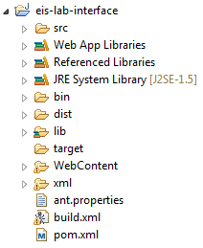

Illustration 4‑6, EIS-LAB-INTERFACE structure

The folders are defined as you can see in the image below are:

* Src: This package contains the implementation of the Backing beans that are used by de User Interface.
* Lib: In this folder are located all the libraries that the project need to run, including the eis-lab.jar
* Dist: Here are located all the files that are generated once you compile the project and execute the ant file (build.xml as you can see in the image).
* WebContent: In this folder are located all the files related with the User Interface (the css file, the. xhtml files and the configuration files need it to run the project on the server).

#### Src Folder:

In this folder are located all the java classes that work as a Backing Beans, basically there are two classes ProcessDataSetBean.java and QualityBean.java, both of them are in charge to managed the two different options that offer the UI, the first one is only provide the tools to show the results after run and evaluate the metrics over some datasets.

The second one is in charge to provide all the necessary things to evaluate a new dataset.

#### WebContent Folder:

This Folder provides all the structure files that are need it to run the process in the JBoss server, here is in detail the folder structure:

* 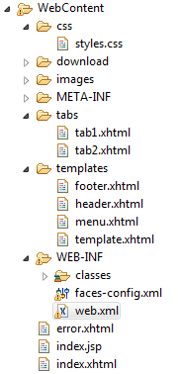The Css folder contained the style sheet that is used by the web application.
* The download folder contained the eis-lab.jar file that can be download it, on the web interface once the project is running in the server.
* The images folder is located the images that use the UI.
* The META-INF folder is needed for the server to provide information once it is running.
* The tabs folder contained the information of every tab of the main page of the project and provides the functionality that is display to the user.
* The templates folder provides the template that is used by the UI.
* In the WEB-INF folder are located all the classes after compilation, once the project is deploy on the server it contained the .class files.

Illustration ‑, WebContent structure

* Also in the WEB-INF folder are located the files faces-config.xml and web.xml, the first one contains the definition of the backing beans (Is the one that configure the jsf), the second one save the configuration related with navigation rules of the system or the configuration of the Web application.
* Also in the folder are located three independent files, the main one is the one that is call index.xhtml that is the one that is process it once the user access to the system.

#### Ant Files

The ant file is in charge to build the entire project automatically and help the users to build the project and its dependencies.

The ant.properties contained the paths for the server of the maven installation directory and the JBoss installation directory.

The build.xml file is the executable ant, which the user should run to build the project.

# TESTING

## JUnit Test

|  |  |  |  |  |
| --- | --- | --- | --- | --- |
| **Requirement Name** | JUnit testing | | | |
| **Priority** | High | | | |
| **Author** | Rauf Aghayev,  Vugar Aghayev  Carlos Montoya | | **Creation Date** | 02-08-2014 |
| **Revision Date** |  | | **Modifications Date** |  |
| **Summary** | This section of documentation shows JUnit testing results for metric classes. For every metric class result of JUnit testing will be shown. For this purpose local data dumps was used. | | | |
|  | | | | |
| **Verifiability – Authenticity** | | **Explanation** | | |
| Operations have been done in 801 milliseconds  Metric value positive: 1.0  Metric value negative: 0.0 | | The test made the assertions loading two datasets, one to assert if the dataset contain information related with the authenticity, the metric return 1 if the information is contained, and 0 if not. | | |
| **Verifiability – Digital Signature** | | **Explanation** | | |
| Operations have been done in 801 milliseconds  Metric value positive_1: 1.0  Metric value positive_2: 1.0  Metric value negative: 0.0 | | The test made the assertions loading three datasets, two of them are use to assert if the dataset contain digital signatures, the metric then should return 1 if the digital signature is contained, and 0 if not. | | |
| **Free Of Error** | | **Explanation** | | |
| Operations have been done in 767 milliseconds  Metric value : 0.8368 | | This screenshot shows output of “testFreeOfError” method. 98 triples was loaded from data dump in 22 seconds and 84% of them are free of error. This percentage calculated by number of free of error triples divided by number of all triples. | | |
| **Measurability** | | **Explanation** | | |
| Operations have been done in 1 seconds  Metric value: 1.0 | | The screenshot depicts results of computation. The program run very fast, even it doesn’t take 1 second. The reason behind metric value was introduced during documentation of metric classes. It outputs 1.0 if data is measurable 0.0 if it is not. | | |

## Performance Test

|  |  |  |  |  |  |  |  |  |
| --- | --- | --- | --- | --- | --- | --- | --- | --- |
| **Requirement Name** | | | Performance Test | | | | | |
| **Priority** | | | High | | | | | |
| **Author** | | | Rauf Aghayev,  Vugar Aghayev | | | **Creation Date** | 10-09-2014 | |
| **Revision Date** | | |  | | | **Modifications Date** |  | |
| **Summary** | | | This section of documentation shows Performance Testing. For this two different approaches was used. First approach is storing RDF triples in apache server, in repositories and accessing them from Eclipse by using <http://localhost:8080/openrdf-sesame/repositories/Data_Set_Name>*.*  Second approach is accessing RDF triples by using global IP - <http://es.dbpedia.org/sparql> | | | | | |
|  | | | | | | | | |
| **Apache Server** | | | | | | | | |
| **Source** | | **Number Of Triples** | | | **Running Time** | | |
| <http://localhost:8080/openrdf-sesame/repositories/Data_Set>  Data dump was taken from-  https://developers.google. com/freebase/data | | In data set there are 2.1M number of triples but for testing 500.000 of them was loaded. | | | 35 seconds | | |
| **Global Store** | | | | | | | | |
| **Source** | **Number Of Triples** | | | **Running Time** | | | |
| http://es.dbpedia.org/sparql | In data set there are more than 10M number of triples but for testing 500.000 of them was loaded. | | | 53 seconds | | | |

# INTALLATION AND USER MANUAL

## INSTALLATION FOR DEVELOPMENT

With the aim to maintain or to extend the eis-lab application there is need to configure the development environment, which consist on the following software:

* Java JDK 5.0
* Eclipse
* JBoss 2.3.GA

After complete the installation of the need it software, it is need it to configure each of them.

### Eclipse

Eclipse is an IDE ([integrated development environment](http://en.wikipedia.org/wiki/Integrated_development_environment)); this one is the tool that allows to modify or to change the java code.

#### Configuration

The source code[10] that is attached to the Project, then you are going to find a folder that contained the two projects that are necessary to run the program on the development environment.

To import the Project to eclipse you should import the Projects to the IDE.

Once it is done you should have something like the next image:

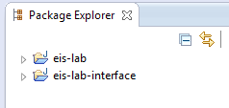

Illustration 6‑1, Projects imported

On the path eis-lab/src/main/java you should have one file that is call config.properties (see Illustration 4-3).

On this file you should configure the two properties displayed, they look like this:



Illustration 6‑2, config.properties file

The first one is the directory where the program is going to store the results, and the default user mail to send the results after running the program (the program takes a lot of time while it runs, it has to stream millions of data).

### JBoss 4.2.3 GA

The JBoss is the applications server where it deployed the eis-lab application.

#### Configuration

After the JBoss installation you should configure the ant.properties file that is located in the eis-lab-interface project, to specify the installation path.

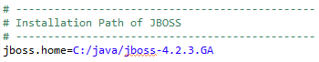

Illustration 6‑3, ant.properties - JBoss path

### Maven

Maven is used by the project to provide all the libraries need it to run the Project over RDF datasets.

#### Configuration

Also you should configure the ant.properties file that is located in the eis-lab-interface Project.

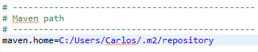

Illustration 6‑4, ant.properties - Maven path

### Run the program on the server

Now that everything that is necessary, the project it is able to be deployed into the JBoss server, to do that you should go to the file that is located in the project eis-lab-interface. Your IDE should have installed the tools to run the ant files.

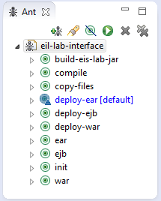

Illustration 6‑5, ant build view

In this view the user only have to give double-click on the mark on blue (deploy-ear), this process creates all the necessary files and copy them to the JBoss server. Also this process copy all the files to the directory eis-lab-interface/dist, this is useful if you want to send only the .ear files or the .jar files to another user.

After execute the ant build, it is necessary to run the JBoss server, to do this you have to go to the JBOSS_HOME\bin and then start the server.

To see the program you need to open the web page: <http://localhost:8080/EIS_LAB_QAENTLOD/index.jsf>.

## USER MANUAL

### Flow of the program.

To understand how it works the processing of the program you should understand the producer-consumer problem[11]. In this lab, the problem is solved in the project eis-lab in the package de.unibonn.iai.eis.qaentlod.io.streamprocessor.

This is implemented to improve the times that takes to stream one SPARQL endpoint, because usually these endpoints contained millions of RDF points of information.

Then the producer in in charge to establish the connection to the SPARQL endpoint, then using SPARQL queries it retrieved all the information by batches of size 10000 triples per time[12].

While the producer is calling the information, the consumer is running and waiting for all the information that is published by the consumer.

In the consumer are located all instances of the Quality Metrics, so in every lecture that the program does it send to every metric to compute the value of the metrics.

This process continue while the producer is publishing information, when this one stops, then the consumer received the message that there is no more information pending to be publish. So it continues to end the program.

After ending the consumer, with all the values obtained by the metrics, it goes and save the information of every metric into the File that is design for this (the path was configured in the section 6.1.1.1).

The final step is that the client sends a mail of confirmation when the process is done. Next is a sequence diagram to explain the process.

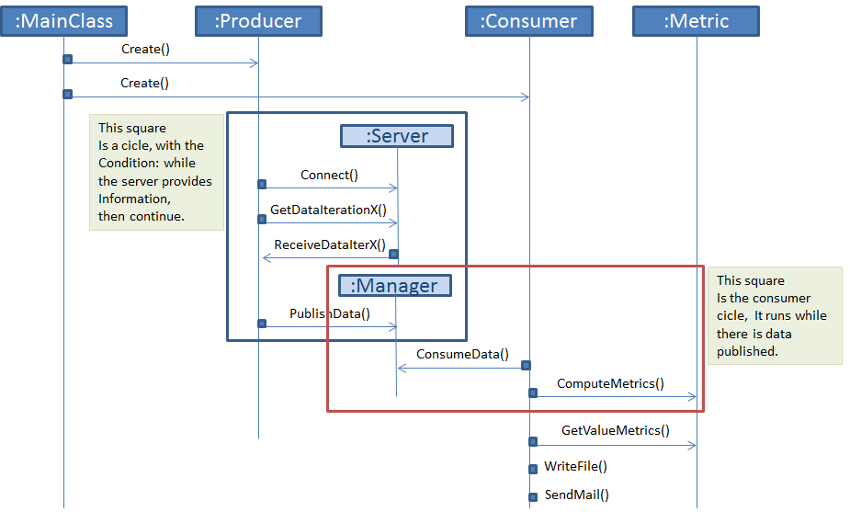

Illustration 6‑6, Sequence diagram

### How to Access and use the program.

To access to the web application the user need to access on the Web navigator to the link: <http://localhost:8080/EIS_LAB_QAENTLOD/index.jsf>.

Once it is running the user should be able to see the next things.

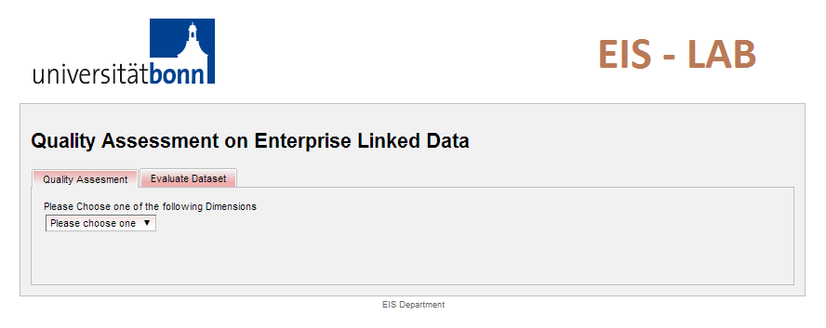

Illustration 6‑7, Init screen

There are two different functionalities available in the system:

#### Visualize results

The first tab was created with the aim to visualize the results; to make it work the user should follow the next steps.

First the user should choose one of the dimension that are display on the select panel, the next image show how it works.

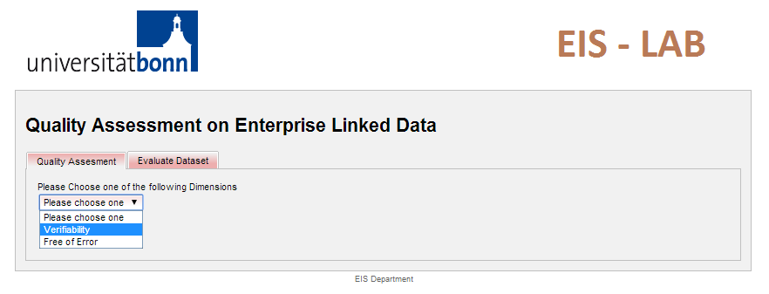

Illustration 6‑8, Available dimensions

When the user has selected one of the dimensions then the system shows a new selectable combo box as shown in the next image.

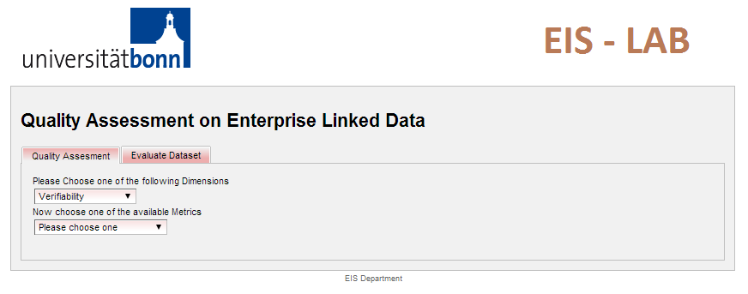

Illustration 6‑9, Metrics select combo

The user should select one of the available dimensions, once this is done, then the system display a new combo box, to show the available Data Sets that already had been evaluated.

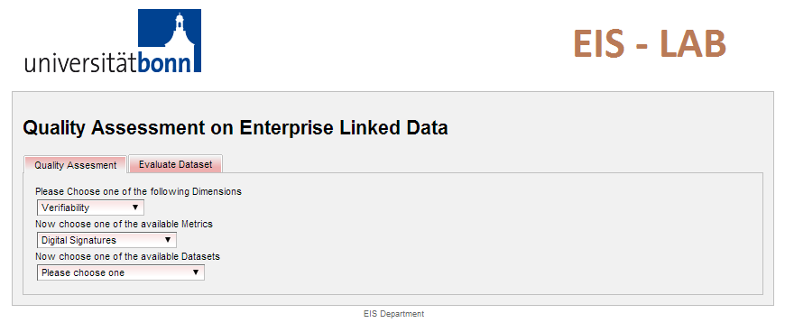

Illustration 6‑10, Available Datasets

Then the user should select one of the datasets to see the results of this metric over the data set.

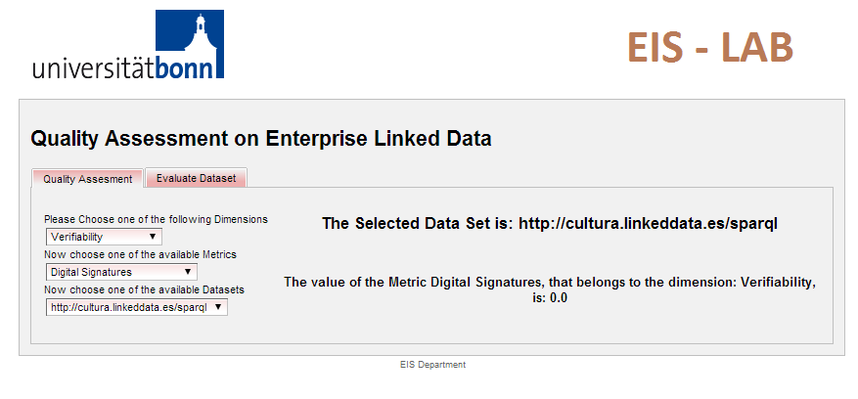

Illustration 6‑11, Result Image

#### Evaluate new Dataset

The second tab provide by the system is in charge to evaluate a new data set or can be used to reevaluate one of the existing datasets.

When the user access to the second tab, the system shows the next screen:

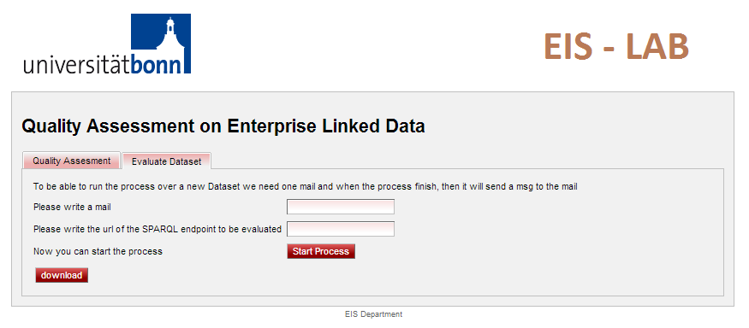

Illustration 6‑12, Evaluate new dataset

Then the user should to fill the information of user mail and SPARQL endpoint and then activate the “Start Process” button, this is going to start the process of evaluate the data set, once the process is done then the program will send an automatic mail to the specified mail.

Also the user can download the eis-lab.jar to work with it if they want to do it. To accomplish this, the user only has to click on the bottom “download” automatically it will be save to the computer.

# REFERENCES

[i]. Zaveri, A. Rula, A. Maurino, R. Pietrobon, J. Lehmann, S. Auer. (2012). *“Quality Assessment for Linked Open Data: A Survey”*. URL: <http://www.semantic-web-journal.net/content/quality-assessment-linked-open-data-survey>

1. <http://www.w3.org/RDF/>
2. <http://en.wikipedia.org/wiki/Jena_(framework)>
3. <http://en.wikipedia.org/wiki/SPARQL>
4. <http://maven.apache.org/what-is-maven.html>
5. <http://en.wikipedia.org/wiki/JavaServer_Faces>
6. <https://javaserverfaces.java.net/>
7. The library can be download it in: <http://www.jboss.org/richfaces>
8. Java Naming Directory Interface, API for the directory services. This allows clients to discover and searching objects and names through a name.
9. <http://en.wikipedia.org/wiki/Apache_Ant>
10. The source code can be download from: <https://github.com/Punkar22/Eis_Lab>
11. <http://en.wikipedia.org/wiki/Producer%E2%80%93consumer_problem>
12. To accomplish this the project use LIMIT and OFFSET, see: <http://www.w3.org/TR/rdf-sparql-query/#modOffset>